Databricks Assignment
Question 1:
Please find the CSV files (Employee, Department, Country)
Questions:
- Create 3 folders as source_to_bronze, bronze_to_silver, silver_to_gold.
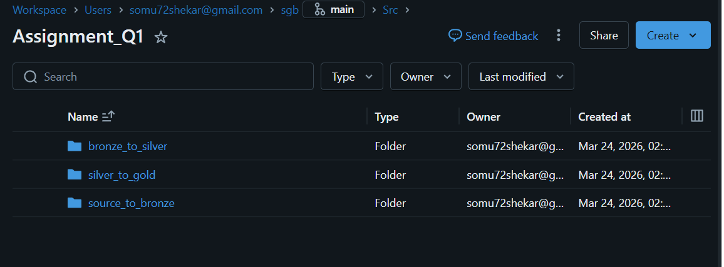
- Create 4 notebooks in this respective order.
- 2 Notebooks named in source_to_bronze as utils (add all common functions in this notebook) and employee_source_to_bronze (driver notebook)
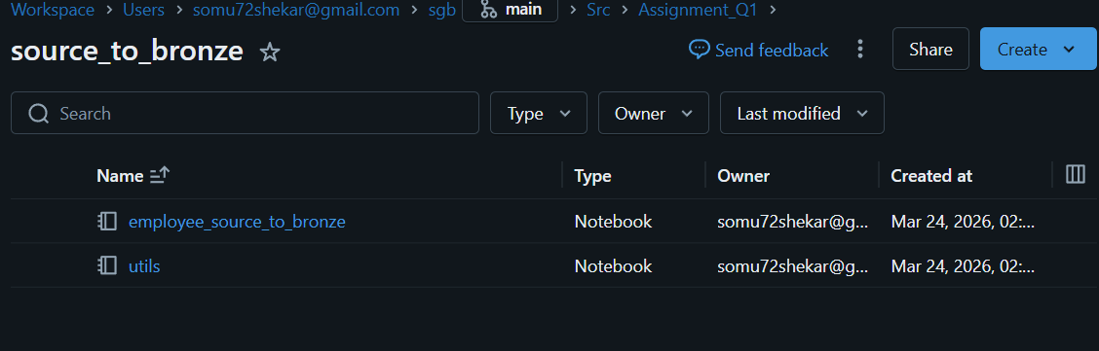
- 1 Notebook in bronze to silver as employee_bronze_to_silver
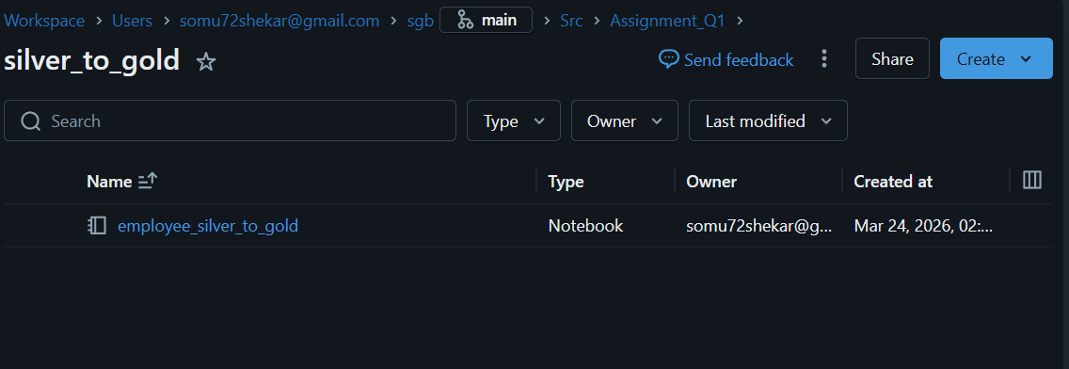
- 1 Notebook in silver to gold as employee_silver_to_gold
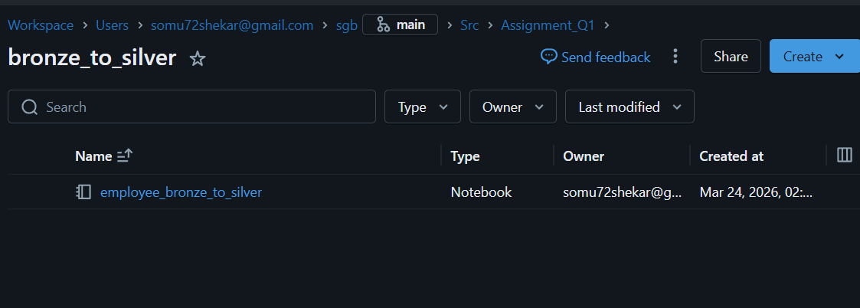
- Read the 3 datasets as Dataframe in employee_source_to_bronze, call utils notebook in this notebook, and write to a location in DBFS,
as /source_to_bronze/file_name.csv (employee, department_df, country_df) as CSV format.
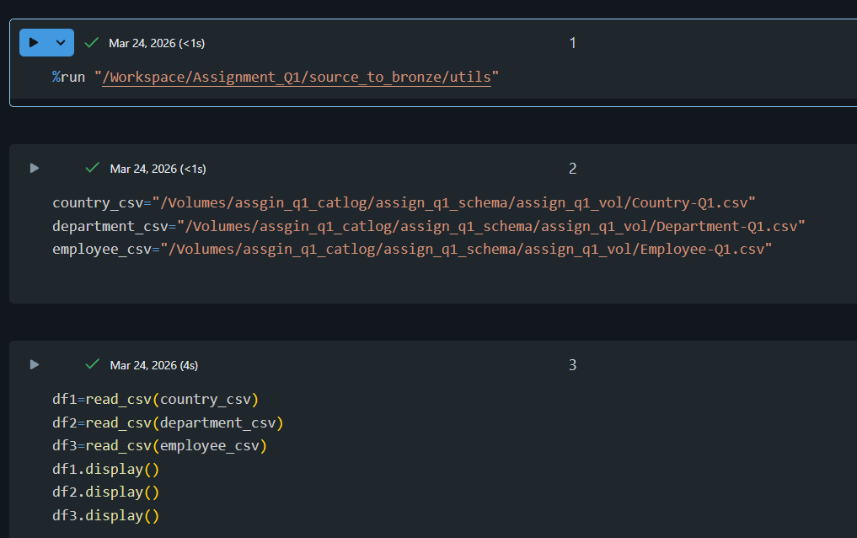
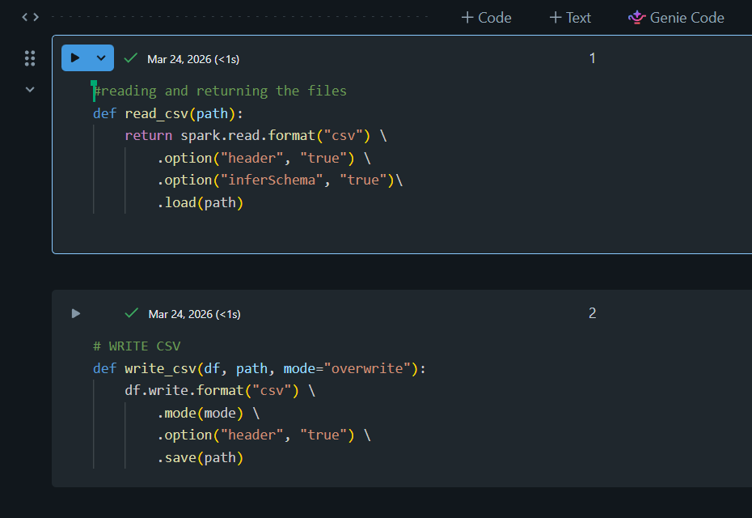

- In employee_bronze_to_silver, call utils notebook in this notebook.
Read the file located in DBFS location source_to_bronze with as data frame different read methods using custom schema.
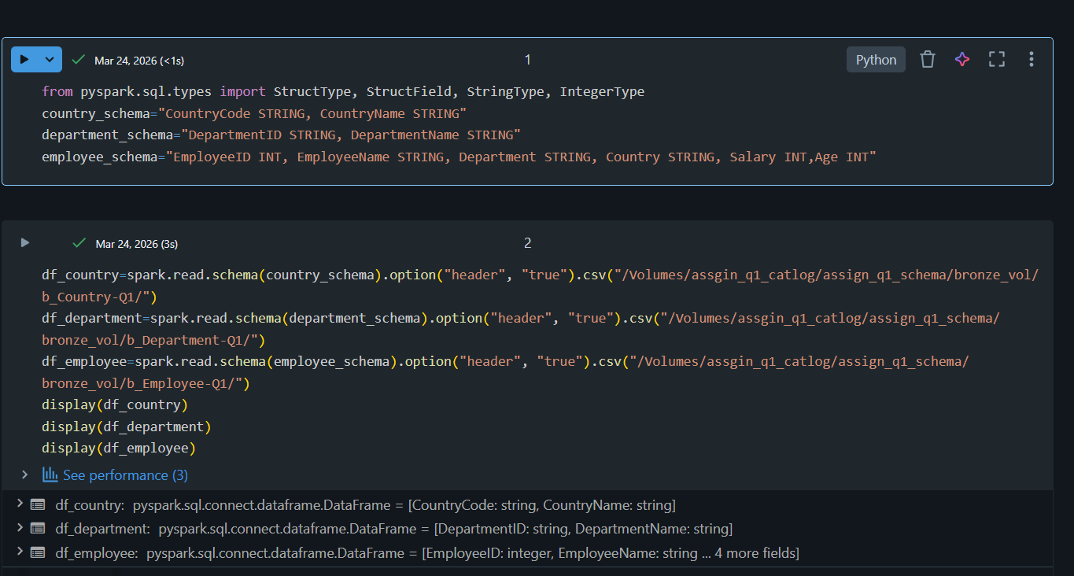
- convert the Camel case of the columns to the snake case using UDF.
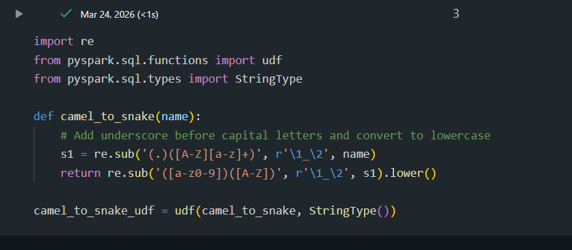
- Add the load_date column with the current date.
- The primary key is EmployeeID, the Database name is Employee_info, Table name is dim_employee.
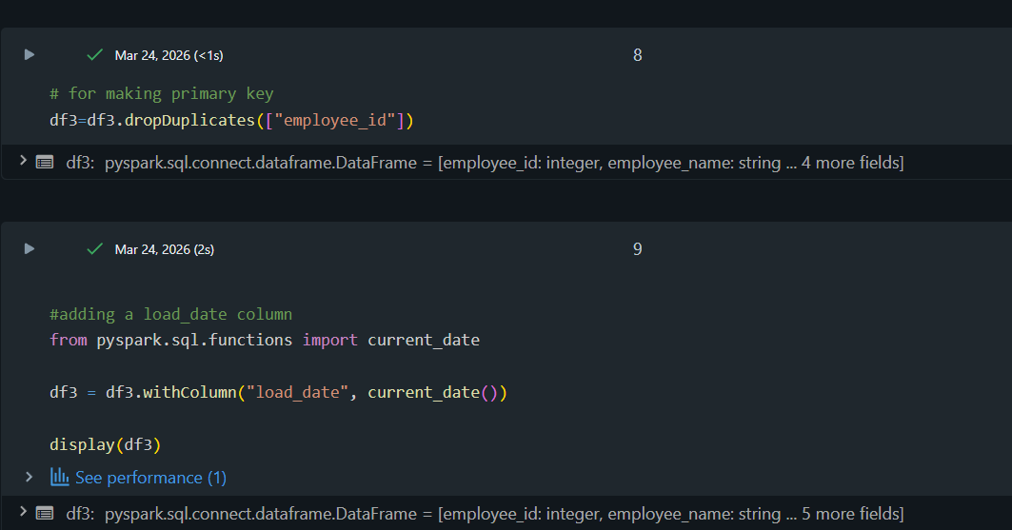
- write the DF as a delta table to the location /silver/db_name/table_name.
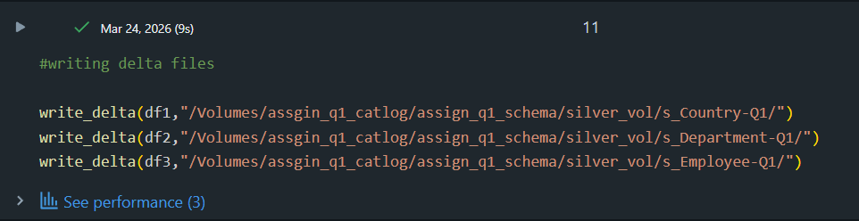
- In gold notebook employee_silver_to_gold, call utils notebook in this notebook
Read the table stored in a silver layer as DataFrame and select the columns based on the following requirements.
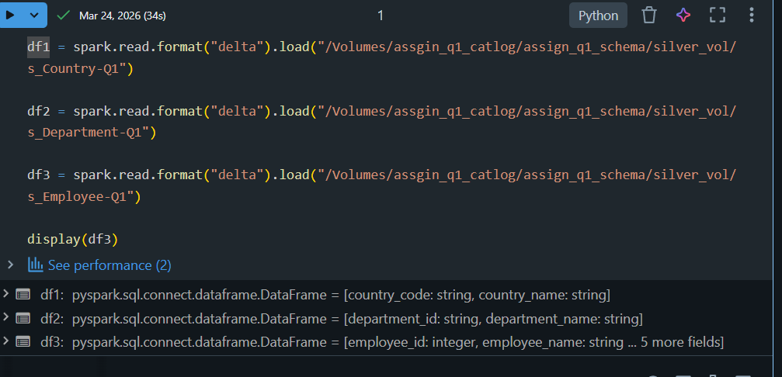
- Requirements:
- Find the salary of each department in descending order.
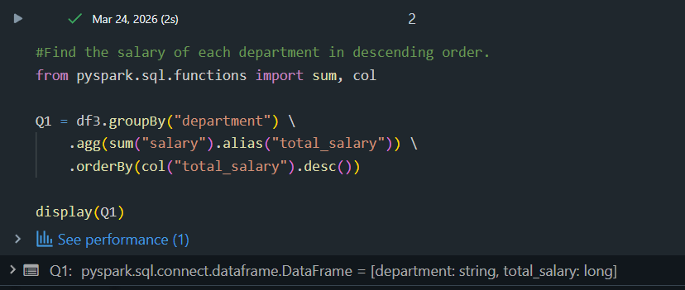
- Find the number of employees in each department located in each country.
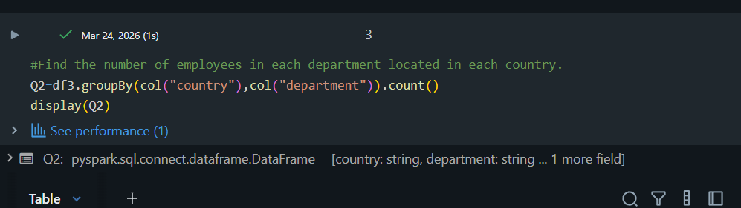
- List the department names along with their corresponding country names.
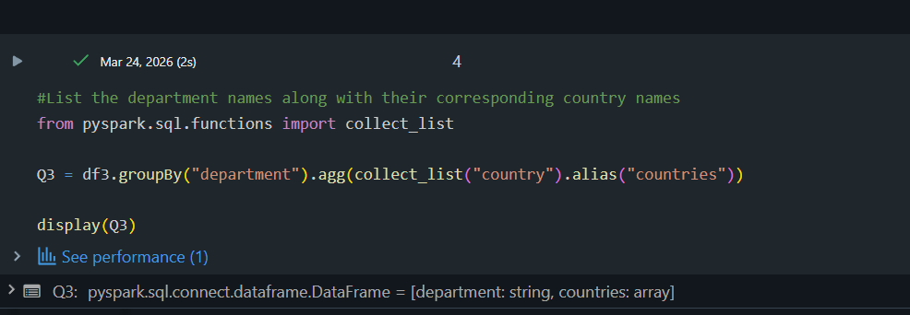
- What is the average age of employees in each department?
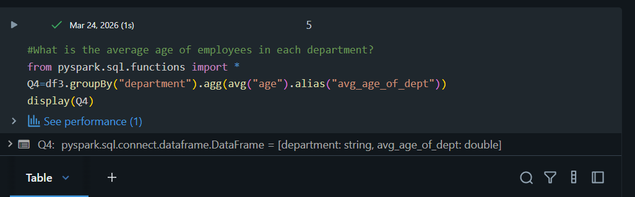
- Add the at_load_date column to data frames.
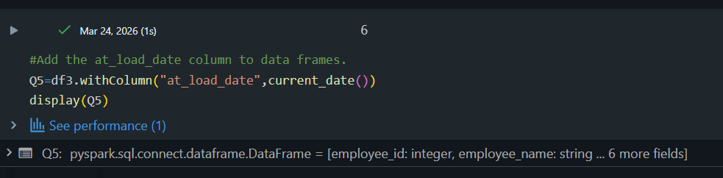
- Write the df to dbfs location /gold/employee/table_name(fact_employee) with overwrite and replace where condition on at_load_date.
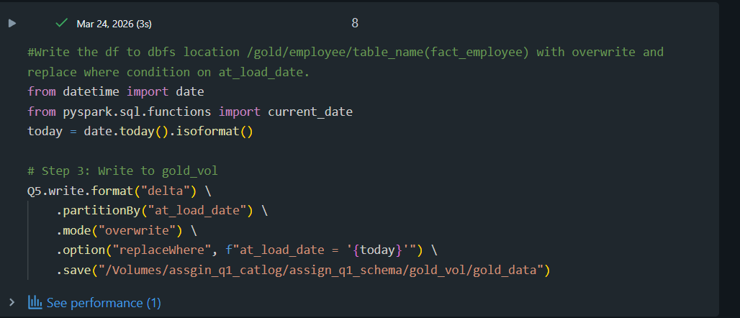

Question 2:
Api: JSONPlaceholder - Free Fake REST API
drop "page”, "per_page", "total", "total_pages" and complete block of support.
- Fetch the data from the given API by passing the parameter as a page and retrieving the data till the data is empty.
- Read the data frame with a custom schema
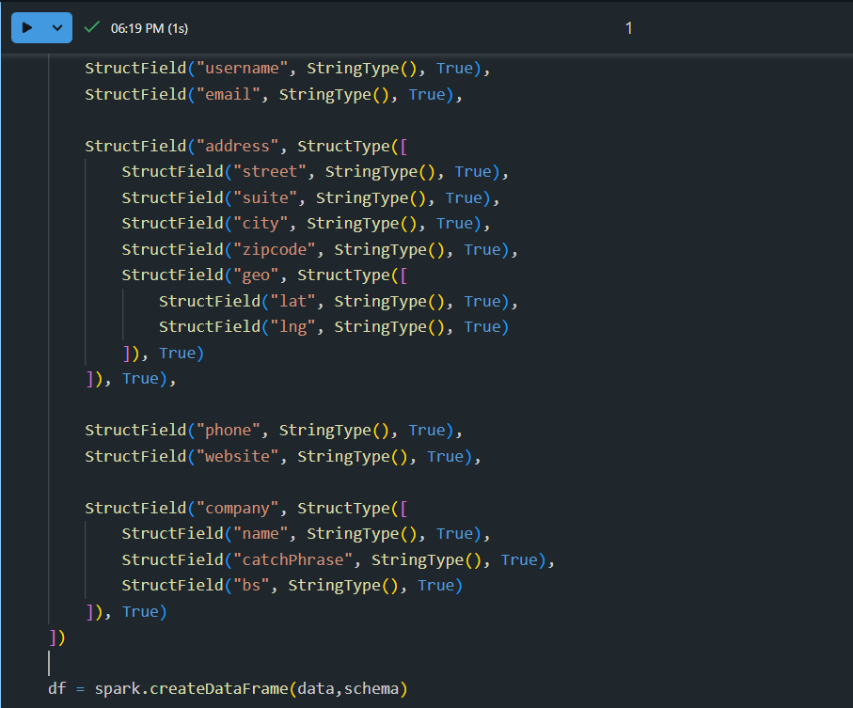
- Flatten the dataframe
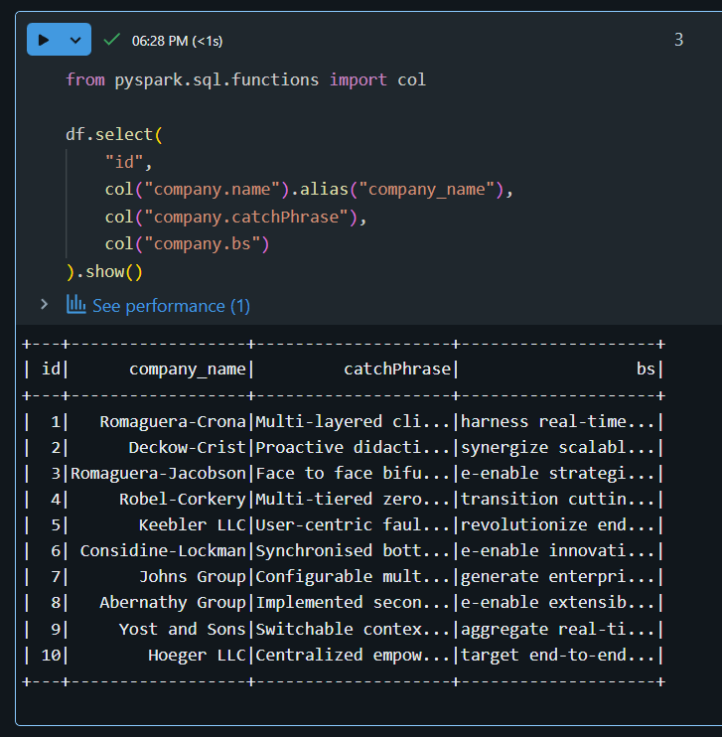
- Derive a new column from email as site_address with values(reqres.in)
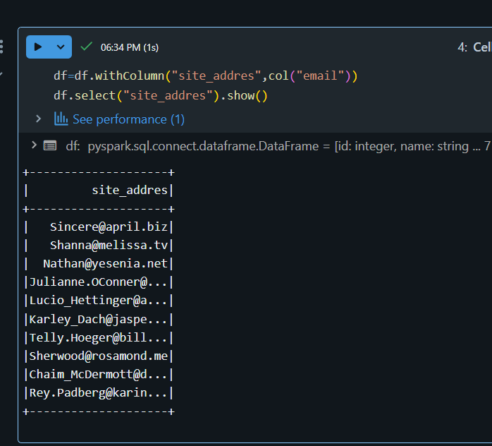
- Add load_date with the current date ‘
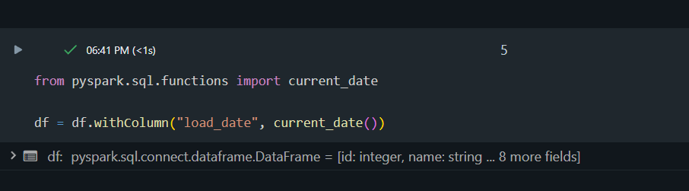
- Write the data frame to location in DBFS as /db_name /table_name with
Db_name as site_info and table_name as person_info with delta format and overwrite mode. 